CNNP- Skill 2

THREE-POINT CAPTURE – Analyze packet captures from three points in a network path to understand packet flow and identify performance differences.

STAGE 1 — Install tools

Open Ubuntu and type the following commands in the Ubuntu terminal

sudo apt update sudo apt install -y tshark iperf3 mtr-tiny iproute2 wireshark netcat-openbsd
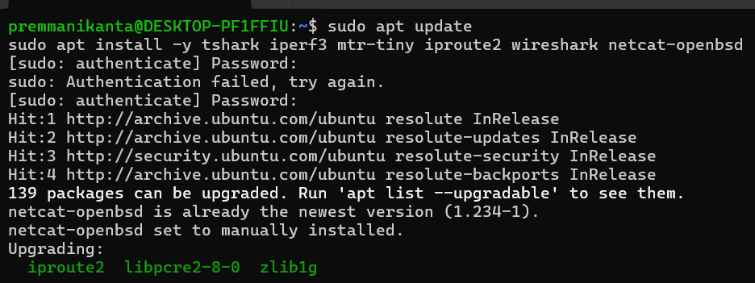

STAGE 2 — Build the network

Open again ubuntu and rename that tab as Terminal 1 and run all of these one by one:

sudo ip netns add host1 sudo ip netns add router sudo ip netns add host2
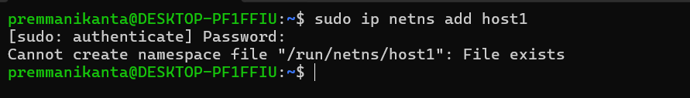
sudo ip link add veth-h1 type veth peer name veth-r1 sudo ip link add veth-r2 type veth peer name veth-h2
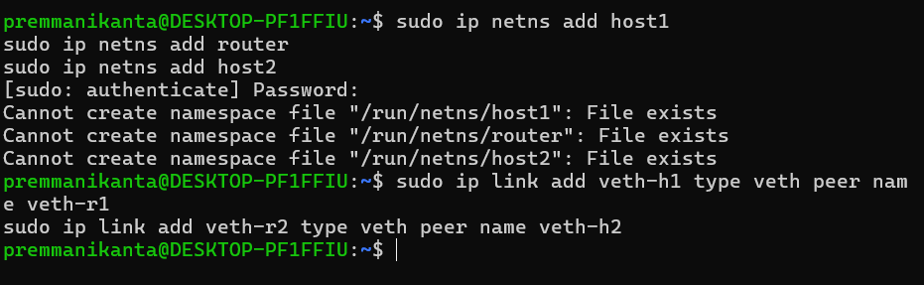

sudo ip link set veth-h1 netns host1 sudo ip link set veth-r1 netns router sudo ip link set veth-r2 netns router sudo ip link set veth-h2 netns host2
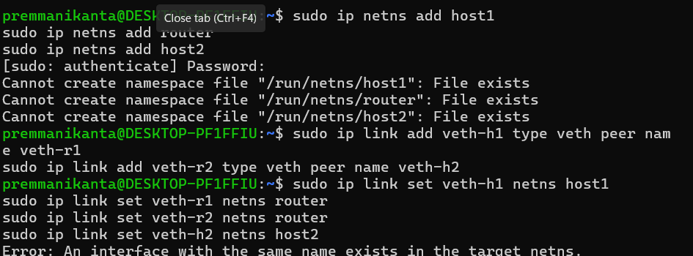

STAGE 3 — Configure IP addresses ( Note: In terminal 1 Only)

host1:
sudo ip netns exec host1 ip addr add 10.0.1.1/30 dev veth-h1 sudo ip netns exec host1 ip link set veth-h1 up sudo ip netns exec host1 ip link set lo up
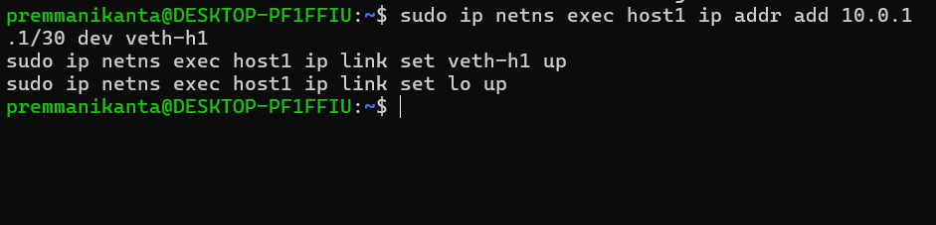
router:
sudo ip netns exec router ip addr add 10.0.1.2/30 dev veth-r1 sudo ip netns exec router ip addr add 10.0.2.1/30 dev veth-r2 sudo ip netns exec router ip link set veth-r1 up sudo ip netns exec router ip link set veth-r2 up sudo ip netns exec router ip link set lo up
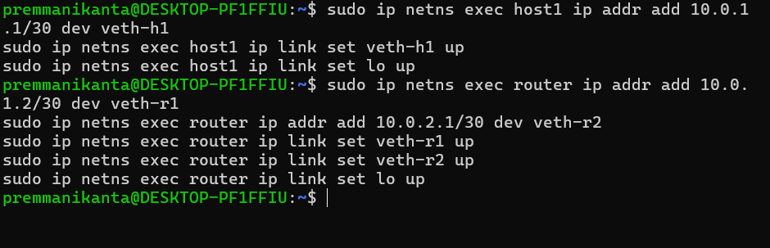

host2:
sudo ip netns exec host2 ip addr add 10.0.2.2/30 dev veth-h2 sudo ip netns exec host2 ip link set veth-h2 up sudo ip netns exec host2 ip link set lo up
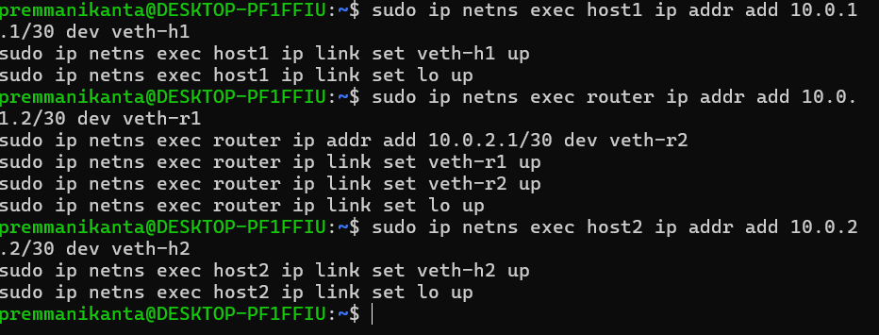

STAGE 4 — Enable routing

sudo ip netns exec router sysctl -w net.ipv4.ip_forward=1 sudo ip netns exec host1 ip route add 10.0.2.0/30 via 10.0.1.2 sudo ip netns exec host2 ip route add 10.0.1.0/30 via 10.0.2.1

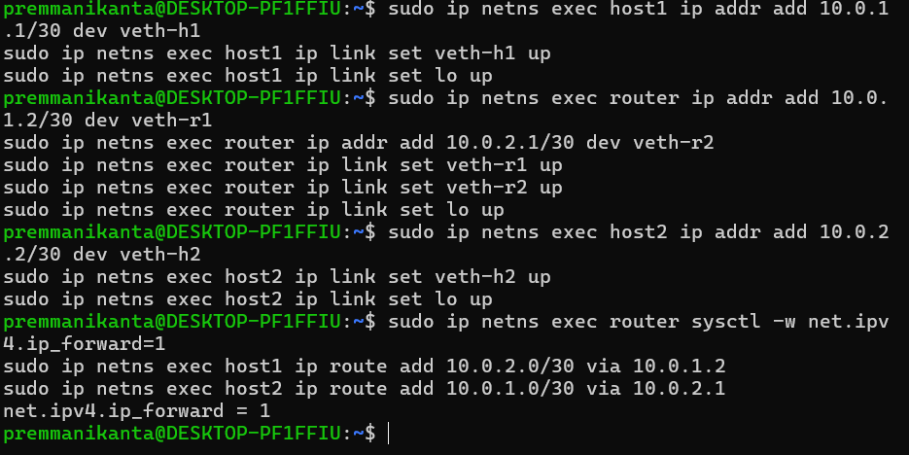

STAGE 5 — Test connectivity

sudo ip netns exec host1 ping -c 3 10.0.2.2

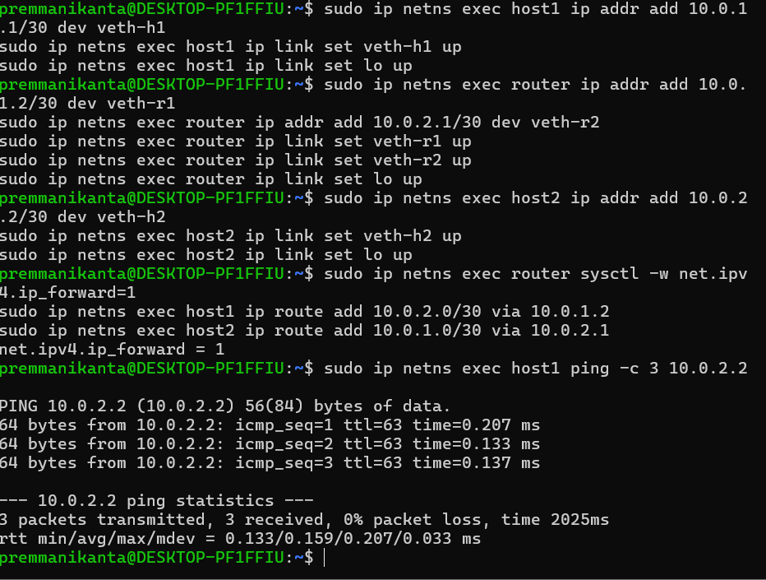
You must see:
3 packets transmitted, 3 received, 0% packet loss

STAGE 6 — Add delay and loss

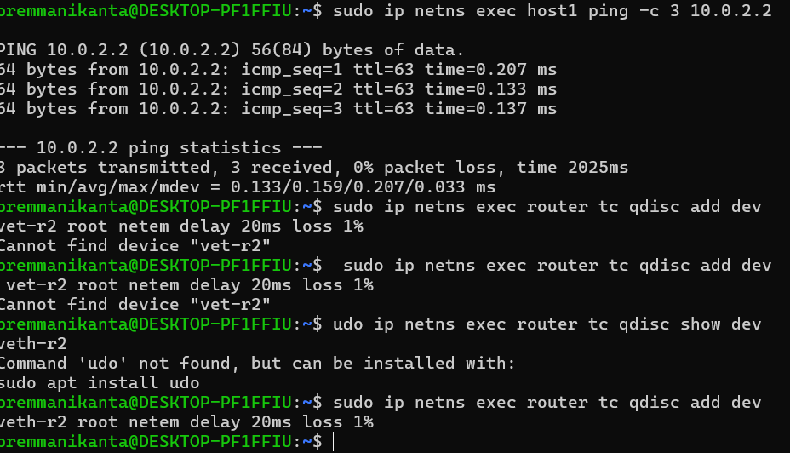

Verify: sudo ip netns exec router tc qdisc show dev veth-r2
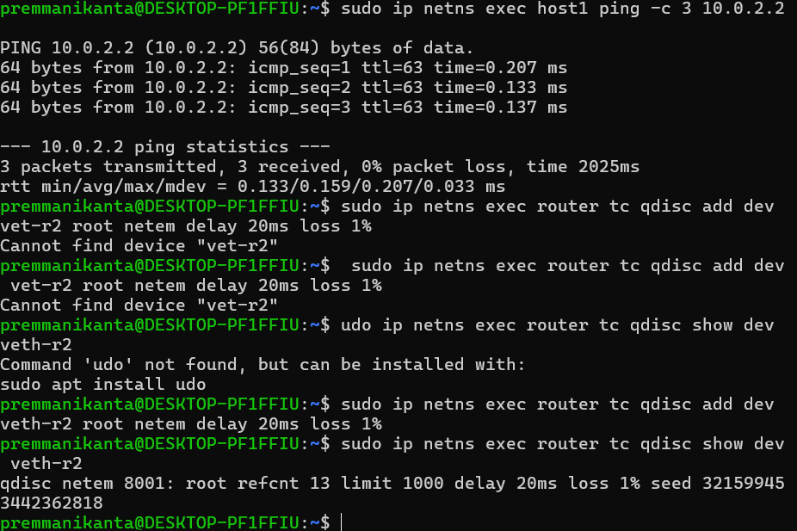

You must see netem delay 20ms loss 1%

STAGE 7 — Open 4 terminals

You need 4 terminals open now.

Terminal 1 — already open (used above)
Terminal 2 — open new (By going to Ubuntu option )
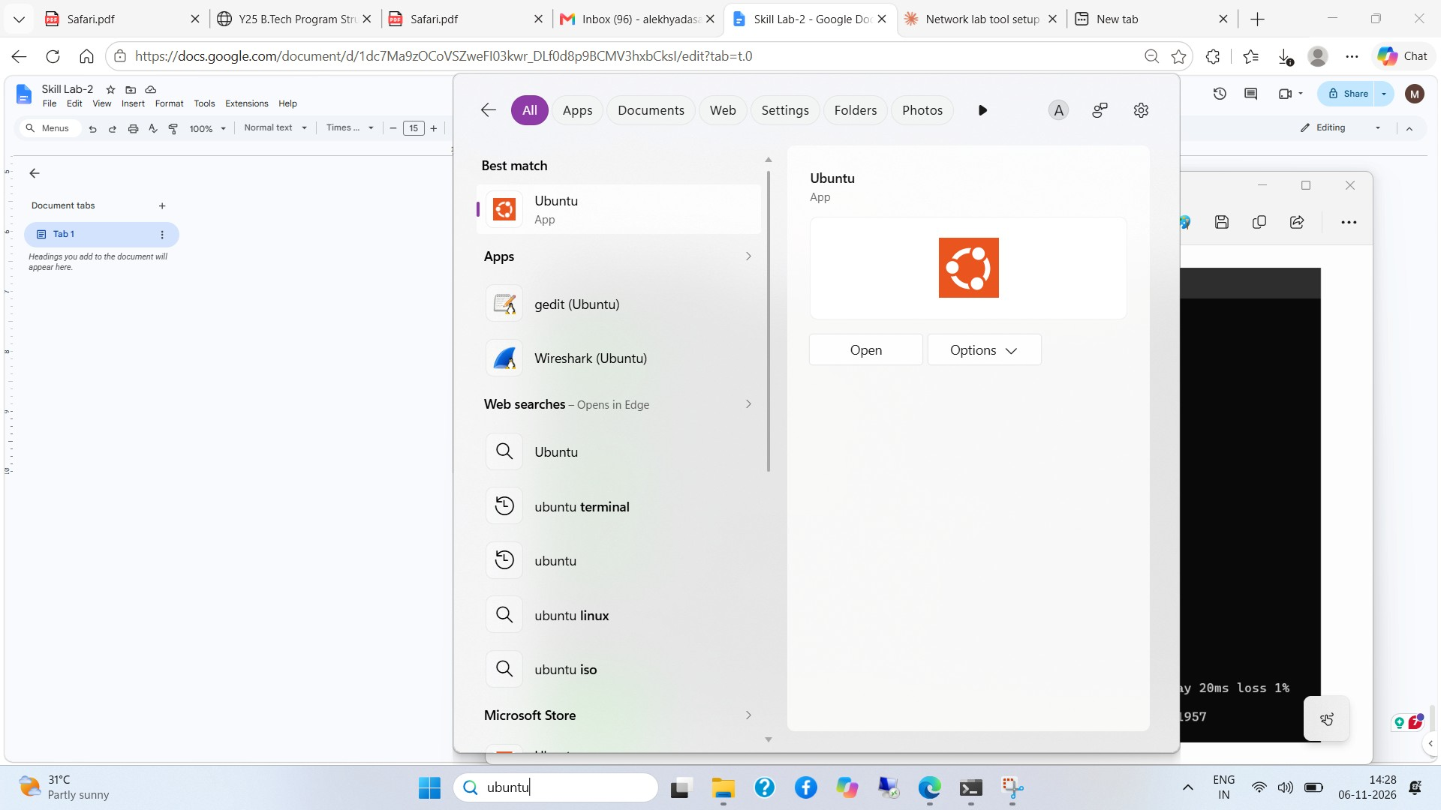
Terminal 3 — open new (By going to Ubuntu option )
Terminal 4 — open new (By going to Ubuntu option )

STAGE 8 — Start three captures simultaneously Terminal 1 — capture at host1 sudo ip netns exec host1 tshark -i veth-h1 -w /tmp/cap1.pcap
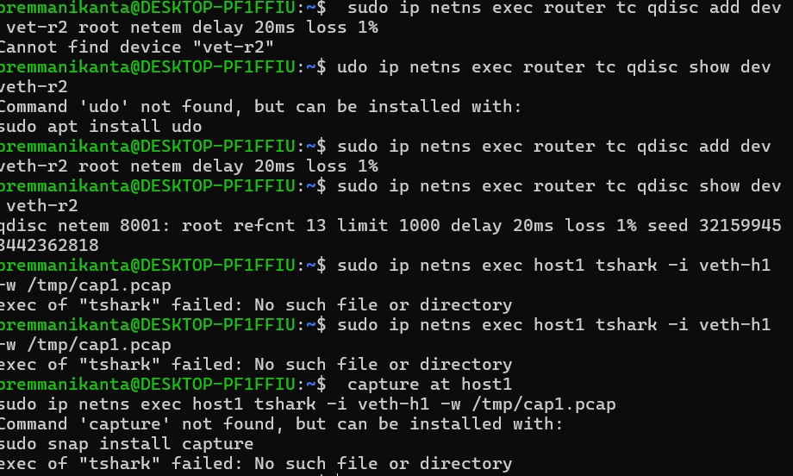
Terminal 2 — capture at router sudo ip netns exec router tshark -i veth-r1 -w /tmp/cap2.pcap

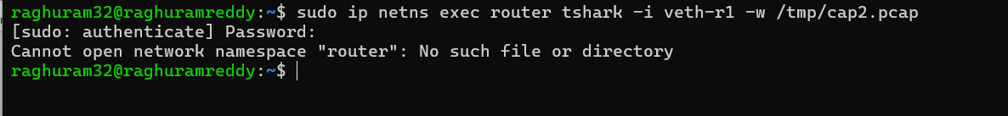

Terminal 3 — capture at host2

sudo ip netns exec host2 tshark -i veth-h2 -w /tmp/cap3.pcap
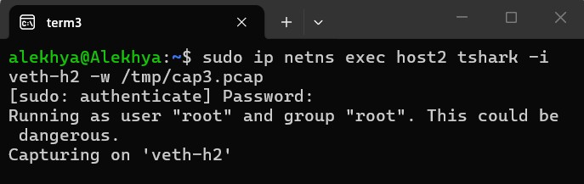

All three show:

Capturing on 'veth-h1'

Leave all three running.

STAGE 9 — Send real message from host1 to host2

Go to Terminal 4.

First start the receiver on host2:

sudo ip netns exec host2 nc -l 1234

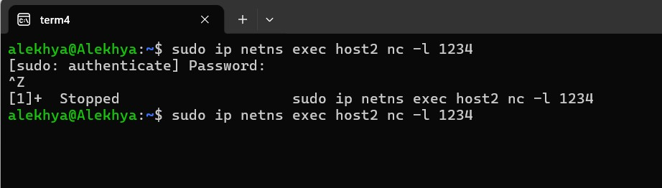
Open a 5th terminal.
Connect from host1:
sudo ip netns exec host1 nc 10.0.2.2 1234
Now type this message and press Enter:
Hello from host1!
Type more messages:
This is Alekhya
Computer Networks Lab
Three Point Capture Experiment
Message traveling through router
STAGE 10 — What you see in real time Terminal 4 (host2) shows your message arriving:
Hello from host1!
This is Alekhya
Computer Networks Lab
Three Point Capture Experiment
Message travelling through router

Terminal 1, 2, 3 (tshark) show packet counts increasing:
Capturing on 'veth-h1'
10 packets
24 packets
31 packets
STAGE 12 — Fix permissions sudo chmod 644 /tmp/cap1.pcap /tmp/cap2.pcap /tmp/cap3.pcap STAGE 13 — Check TTL
tshark -r /tmp/cap1.pcap -T fields -e ip.ttl -Y "ip" 2>/dev/null | sort | uniq -c tshark -r /tmp/cap2.pcap -T fields -e ip.ttl -Y "ip" 2>/dev/null | sort | uniq -c tshark -r /tmp/cap3.pcap -T fields -e ip.ttl -Y "ip" 2>/dev/null | sort | uniq -c
Expected: cap1 → 64 cap2 → 64 cap3 → 63
STAGE 14 — Read your actual message from the capture
tshark -r /tmp/cap2.pcap -Y "tcp.port == 1234" -T fields -e data.text 2>/dev/null
You will see your actual message text extracted from the packet:
Hello from host1!
This is Alekhya
Computer Networks Lab
Three Point Capture Experiment
Message travelling through router

Connect from host1:
TERMINAL 1 — Setup (run all commands here)

Install tools:

sudo apt install -y tshark iproute2 netcat-openbsd wireshark

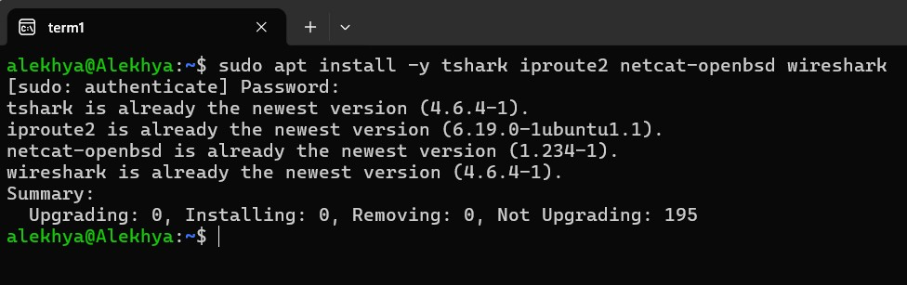

When asked → choose Yes Create 3 nodes:
sudo ip netns add host1 sudo ip netns add router sudo ip netns add host2

Verify:

sudo ip netns list

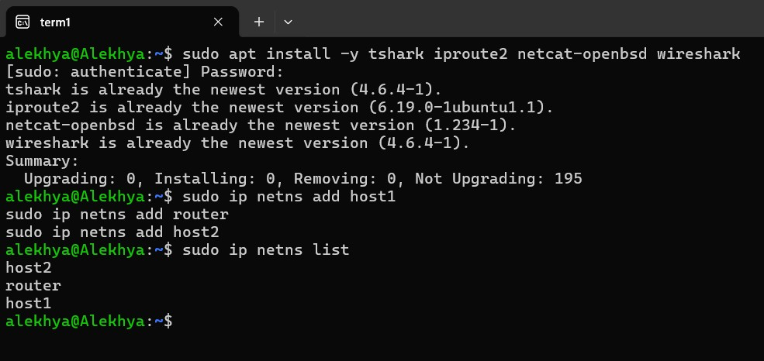

You must see: host1 router host2
Create cables:
sudo ip link add veth-h1 type veth peer name veth-r1 sudo ip link add veth-r2 type veth peer name veth-h2
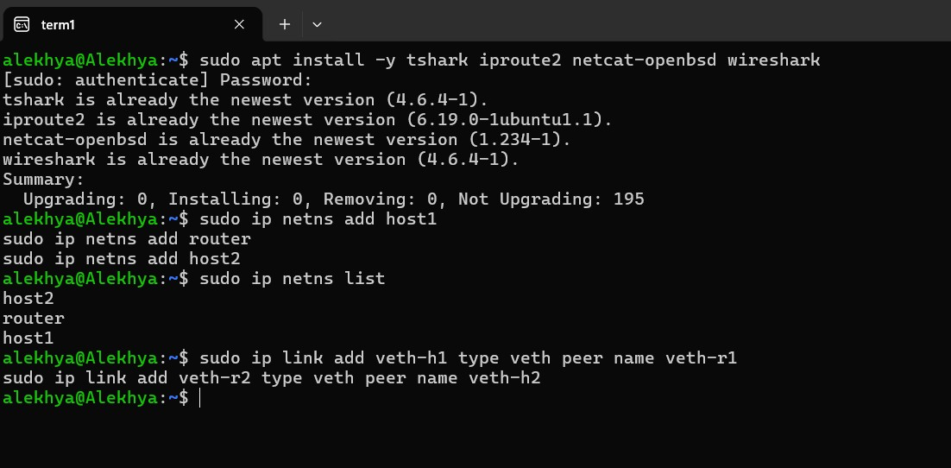

Plug cables into nodes:

sudo ip link set veth-h1 netns host1 sudo ip link set veth-r1 netns router sudo ip link set veth-r2 netns router sudo ip link set veth-h2 netns host2

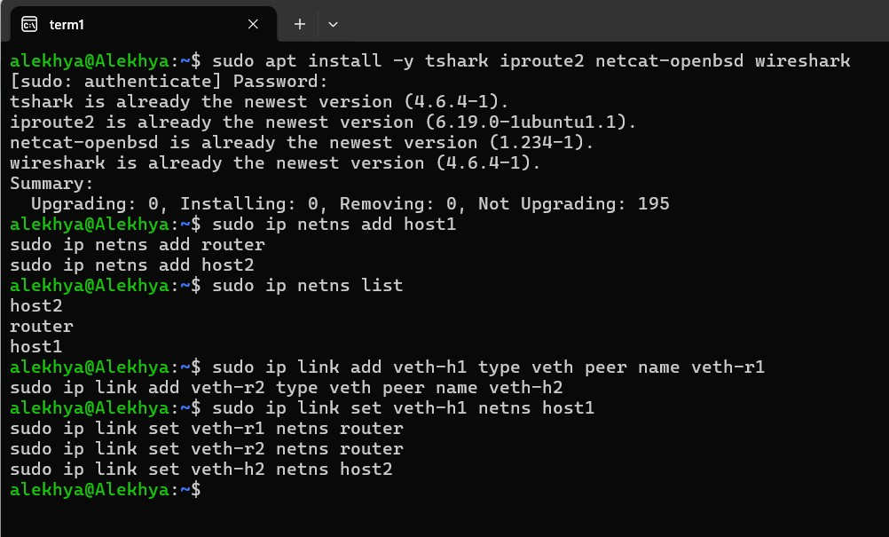

Configure host1:

sudo ip netns exec host1 ip addr add 10.0.1.1/30 dev veth-h1 sudo ip netns exec host1 ip link set veth-h1 up sudo ip netns exec host1 ip link set lo up
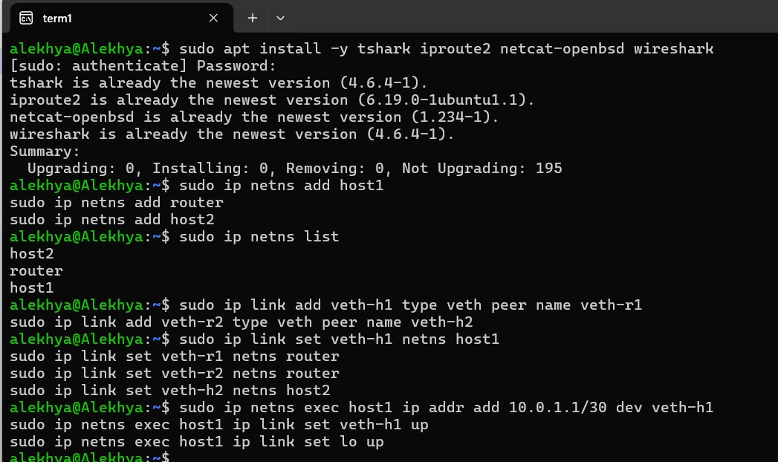

Configure router:

sudo ip netns exec router ip addr add 10.0.1.2/30 dev veth-r1 sudo ip netns exec router ip addr add 10.0.2.1/30 dev veth-r2 sudo ip netns exec router ip link set veth-r1 up sudo ip netns exec router ip link set veth-r2 up sudo ip netns exec router ip link set lo up
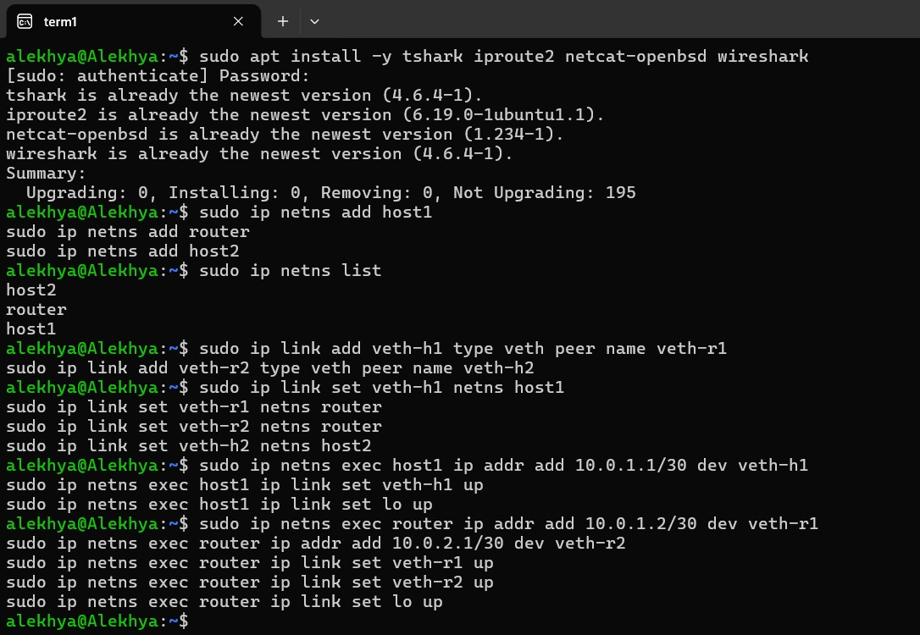

Configure host2: sudo ip netns exec host2 ip addr add 10.0.2.2/30 dev veth-h2 sudo ip netns exec host2 ip link set veth-h2 up sudo ip netns exec host2 ip link set lo up

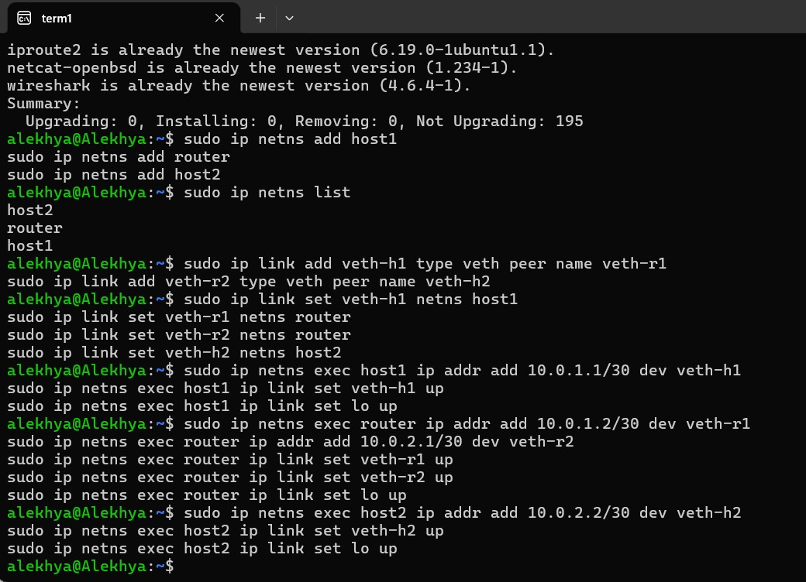

Enable routing:
sudo ip netns exec router sysctl -w net.ipv4.ip_forward=1 sudo ip netns exec host1 ip route add 10.0.2.0/30 via 10.0.1.2 sudo ip netns exec host2 ip route add 10.0.1.0/30 via 10.0.2.1
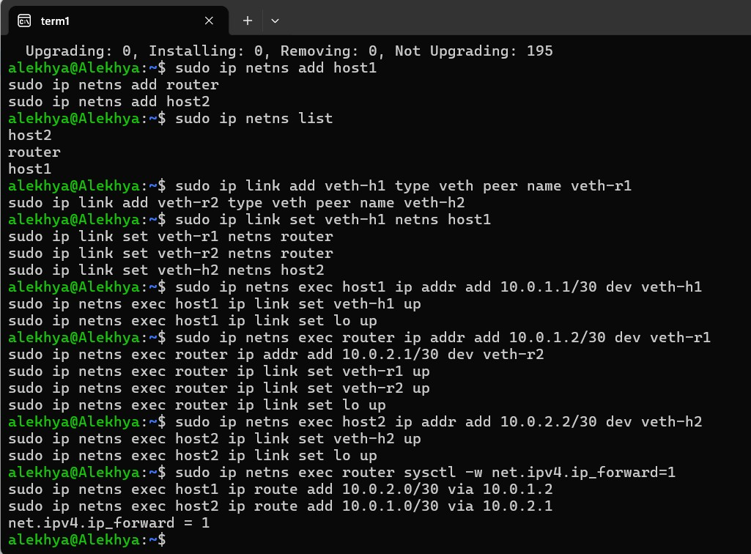

Test connectivity:

sudo ip netns exec host1 ping -c 3 10.0.2.2
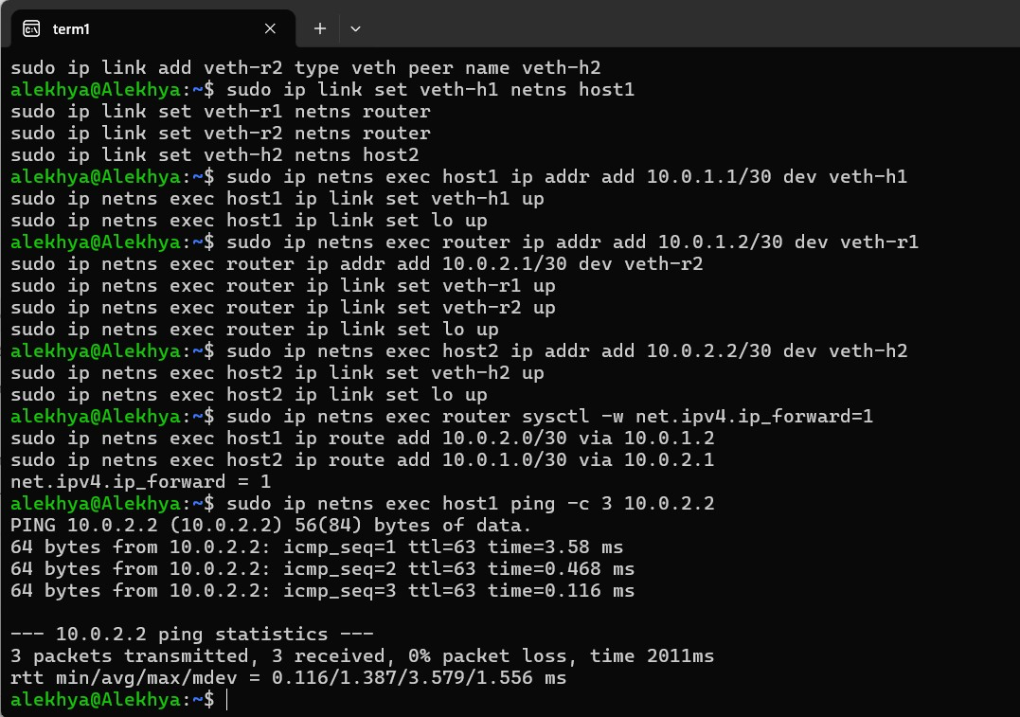

Must see: 3 packets transmitted, 3 received, 0% packet loss

Add delay and loss:

sudo ip netns exec router tc qdisc add dev veth-r2 root netem delay 20ms loss
1%

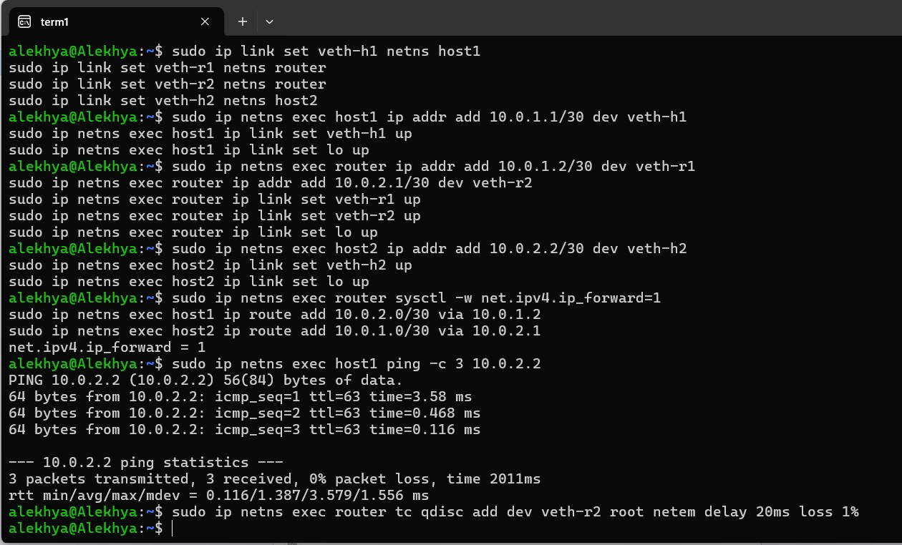

Verify:

sudo ip netns exec router tc qdisc show dev veth-r2

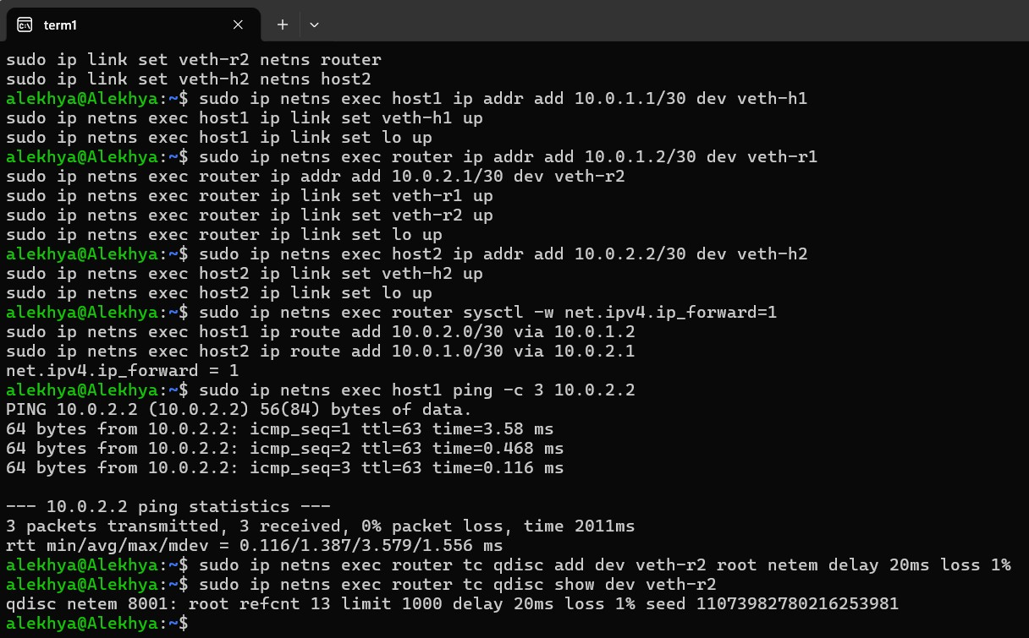

Must see: netem delay 20ms loss 1%

NOW USE ALL 4 TERMINALS

TERMINAL 1 — Capture at host1
sudo ip netns exec host1 tshark -i veth-h1 -w /tmp/cap1.pcap
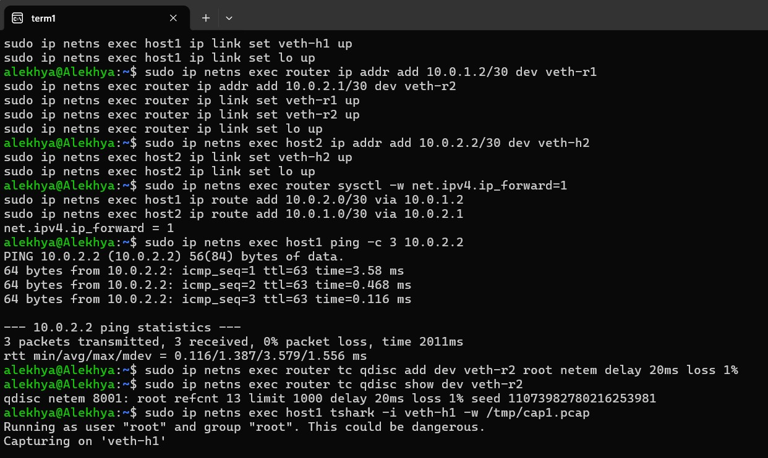

This terminal is left running.

TERMINAL 2 — Capture at router

sudo ip netns exec router tshark -i veth-r1 -w /tmp/cap2.pcap

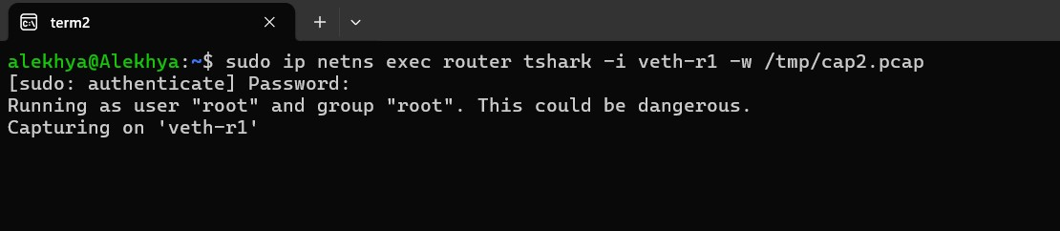

Leave running.

TERMINAL 3 — Capture at host2

sudo ip netns exec host2 tshark -i veth-h2 -w /tmp/cap3.pcap

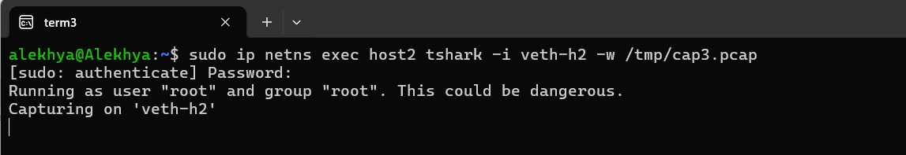

Leave running.

TERMINAL 4 — Send the message
Step 1 — Start receiver on host2:

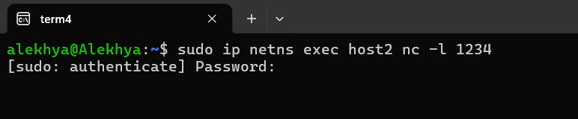
Cursor blinks. Leave it waiting.
Step 2 — Open a new Terminal 5
Step 3 — Connect from host1:

Paste the below command in terminal-5 sudo ip netns exec host1 nc 10.0.2.2 1234
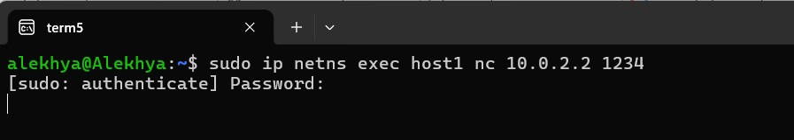
Type the below message in Terminal-5
Hello from host1!
This is Alekhya
Three Point Capture Lab
Message going through router
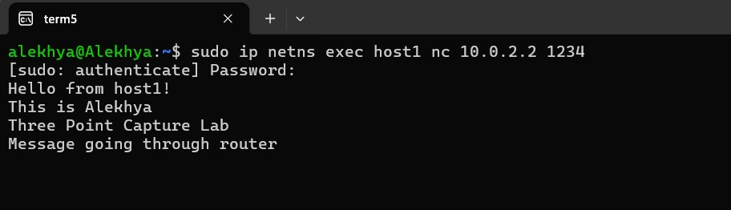

Step 5 — Check Terminal 4 first tab
You will see your message appearing there — that is host2 receiving it.
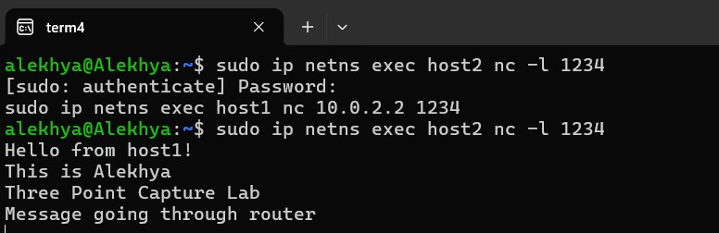
Step 6 — Press Ctrl+C in all terminals
TERMINAL 4 — Analyse results Fix permissions:
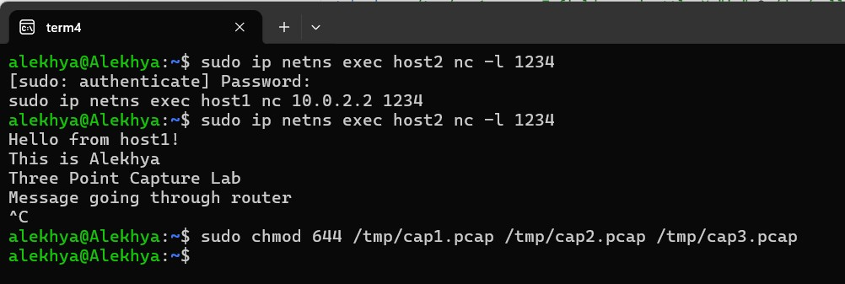

Check files are not empty:
ls -lh /tmp/cap1.pcap /tmp/cap2.pcap /tmp/cap3.pcap
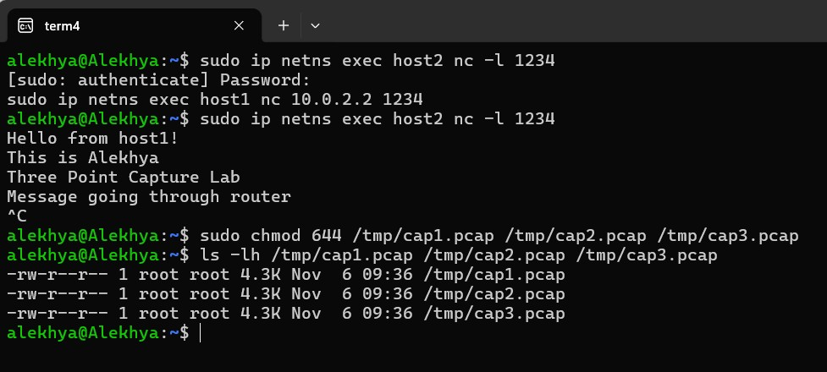

All must show size greater than 0.
Check TTL at all 3 points:
tshark -r /tmp/cap1.pcap -T fields -e ip.ttl -Y "ip" 2>/dev/null | sort | uniq -c tshark -r /tmp/cap2.pcap -T fields -e ip.ttl -Y "ip" 2>/dev/null | sort | uniq -c tshark -r /tmp/cap3.pcap -T fields -e ip.ttl -Y "ip" 2>/dev/null | sort | uniq -c
Expected Outcome:
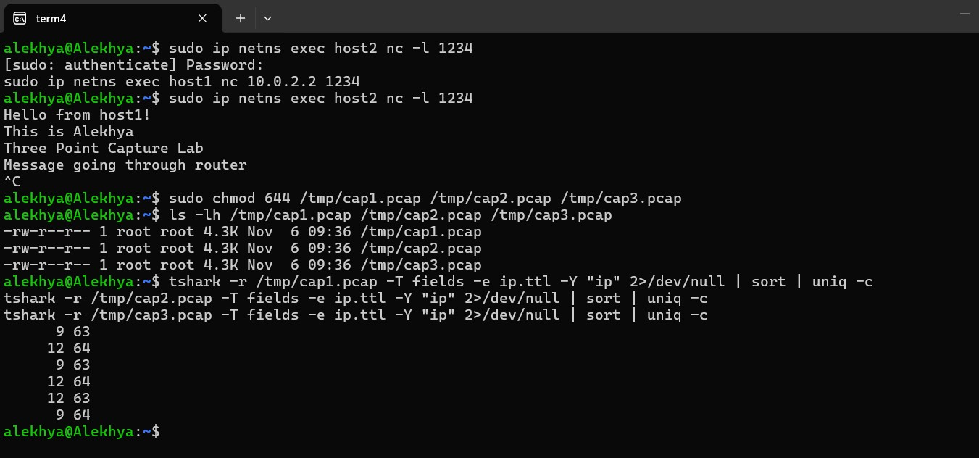

Read your actual message from router capture:
tshark -r /tmp/cap2.pcap -Y "tcp.port == 1234" -T fields -e tcp.payload 2>/dev/null | xxd | head -20
Check delay:
tshark -r /tmp/cap1.pcap -Y "tcp.flags.syn==1 && tcp.flags.ack==0" -T fields -e frame.time_relative 2>/dev/null
tshark -r /tmp/cap2.pcap -Y "tcp.flags.syn==1 && tcp.flags.ack==0" -T fields -e frame.time_relative 2>/dev/null
tshark -r /tmp/cap3.pcap -Y "tcp.flags.syn==1 && tcp.flags.ack==0" -T fields -e frame.time_relative 2>/dev/null Difference between cap1 and cap3 ≈ 20ms
Check retransmissions:
tshark -r /tmp/cap1.pcap -Y "tcp.analysis.retransmission" 2>/dev/null | wc -l tshark -r /tmp/cap2.pcap -Y "tcp.analysis.retransmission" 2>/dev/null | wc -l tshark -r /tmp/cap3.pcap -Y "tcp.analysis.retransmission" 2>/dev/null | wc -l

cap3 shows highest count — loss happened between router and host2.

Check RTT:
sudo ip netns exec host1 mtr --report 10.0.2.2
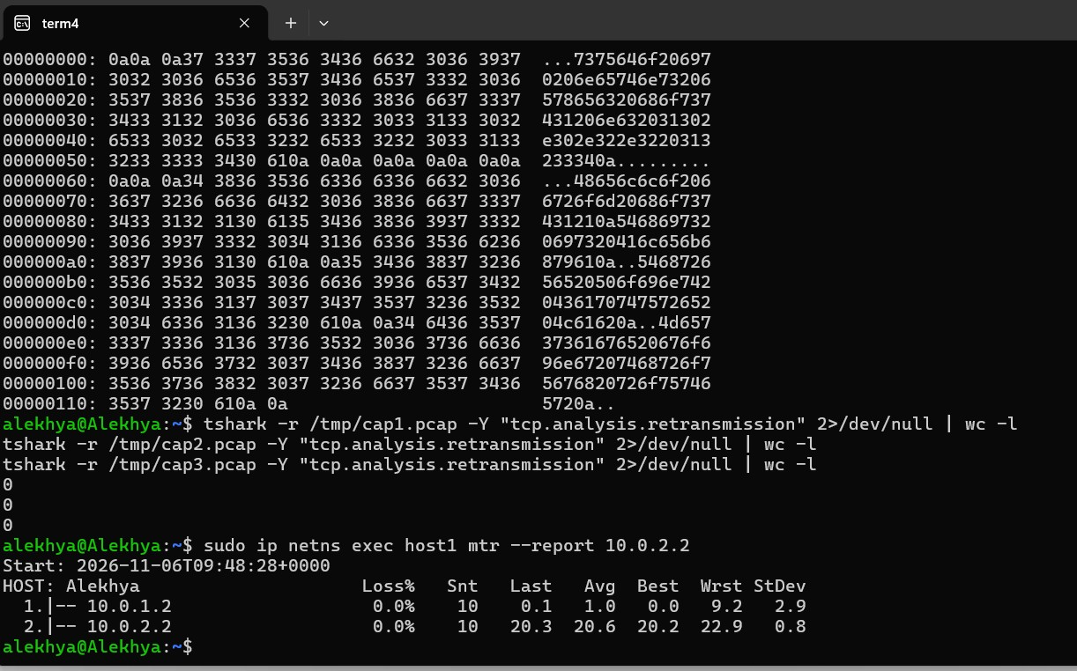
TERMINAL 4 — Open Wireshark wireshark /tmp/cap2.pcap &
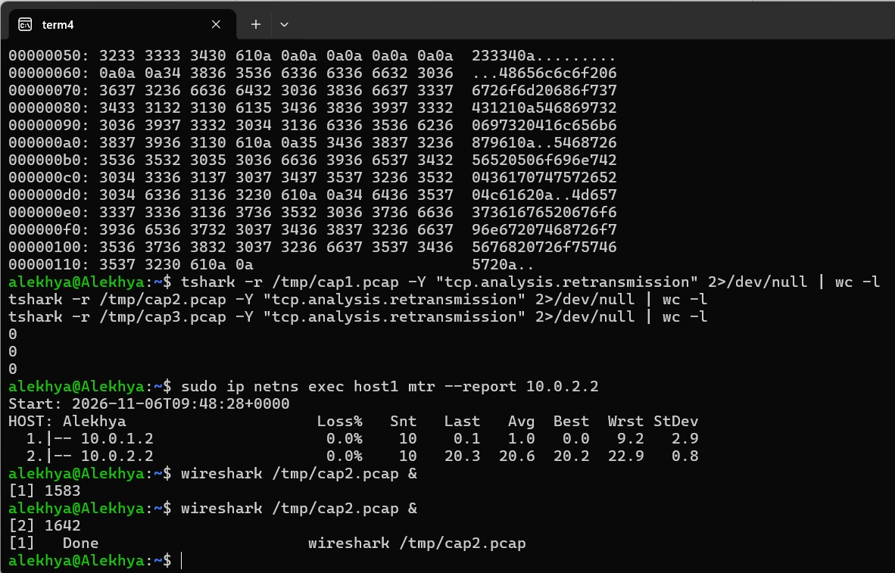

Inside Wireshark: Filter your message only:
tcp.port == 1234
Click any packet → expand middle pane → you will see:

▼ Ethernet II
▼ Internet Protocol Version 4
Time to Live: 64 ← TTL visible here
▼ Transmission Control Protocol
▼ Data
Hello from host1! ← your actual message visible here

Merge all 3 captures:
File → Merge → select cap1.pcap File → Merge → select cap3.pcap
Add TTL column:
Right-click column header
→ Column Preferences
→ click +
→ Title: TTL
→ Type: Custom
→ Fields: ip.ttl
→ OK
Students can now see TTL = 64 at points (1) and (2) and TTL = 63 at point (3)
Show packet loss:
Analyze → Expert Information CLEAN UP — Terminal 4
sudo ip netns del host1 sudo ip netns del router sudo ip netns del host2 Verify: sudo ip netns list
Must return blank.

